IdeationPhase
Brainstorm & Idea Prioritization Template

Date Team ID
Project Name
3 December 2025

SHOPEZ : E-commerce Application


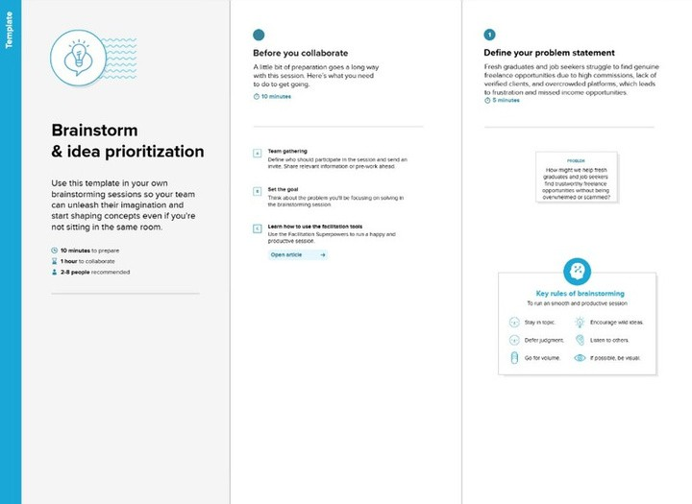
Maximum Marks 4Marks

Brainstorm & Idea Prioritization Template: Brainstorming provides a free and open environment that encourages everyone within a
team to participate in the creative thinking process that leads to problem solving. Prioritizing volume over value, out-of-the-box ideas are welcome and built upon, and all participants are encouraged to collaborate, helping each other develop a rich amount of creative solutions.
Use this template in your own brainstorming sessions so your team can unleash their imagination and start shaping concepts even if you're not sitting in the same room. Reference: https://www.mural.co/templates/brainstorm-and-idea-prioritization
Step-1: Team Gathering, Collaboration and Select the Problem Statement

Step-2: Brainstorm, Idea Listing and Grouping
2
Brainstorm
User login / signup
Browse products Search products Add to cart
Wishlist
Order placement
Payment (COD / Online) Order tracking
Admin can add/edit/delete products Stock management
Simple responsive UI

We listed all the ideas needed for the E-Commerce Application. For users, we included browsing products, searching, adding to cart, wishlist, placing orders, payments, and tracking orders. For admins, we added ideas like adding, editing, and deleting products and managing stock. We grouped these ideas into User Features, Admin Features, System Features, and UI/UX to make the project easier to understand.


3
Group Ideas
User Features: Browse, search, cart, wishlist, order, payment Admin Features: Manage products, manage stock
System Features: Login, signup, secure payment UI/UX: Simple, responsive, fast
2. Seller & Product Management

Dashboard for admin/sellers to manage products
Add, edit, and remove product details
Manage stock and inventory Handle pricing, discounts, and offers

After listing all the ideas during the brainstorming phase, I organized them into clear and meaningful groups to understand the core areas of the E-Commerce Application. The ideas were grouped based on their purpose and the user needs they address.
1. Customer-Centric Features

Easy product browsing by category Search with filters (price, brand, rating)
Add to cart and wishlist Simple order placement and cancellation
Order tracking updates

3. System Automation & Efficiency

Automated order confirmation messages
Real-time stock updates
Alerts for low stock or out-of-stock items
Smooth payment processing

Grouping the ideas in this way helped me understand the major functional areas of the E- Commerce Application and plan the project in a structured and practical manner.

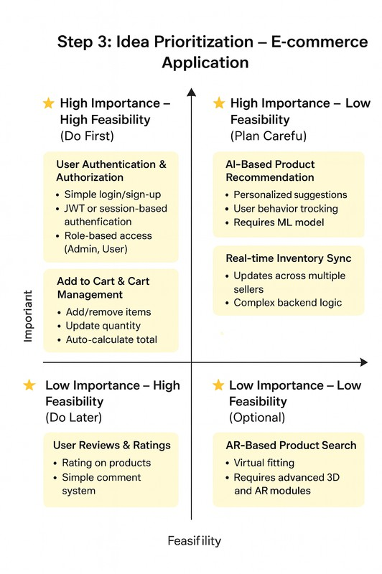
Step-3: Idea Prioritization

